**NAAN MUDHAVAN**

**ASSIGNMENT DOCUMENT**

**COURSE TITLE** : DIGITAL MARKETING

**COLLEGE CODE** : 1105

**COLLEGE NAME** : GOJAN SCHOOL OF BUSINESS AND TECHNOLOGY

**NM ID** : 1DB9BD359D8BD69A0174EF1D29750B94

**NAME** : NISHA G

**REGISTER NUMBER** : 110520106010

**YEAR** : 4TH YEAR

**DEPARTMENT** : ELECTRONICS AND COMMUNICATION ENGINEERING

1. Create a blog or website using Blogspot and Wordpress. Customize the theme design and post new article with 500 words.

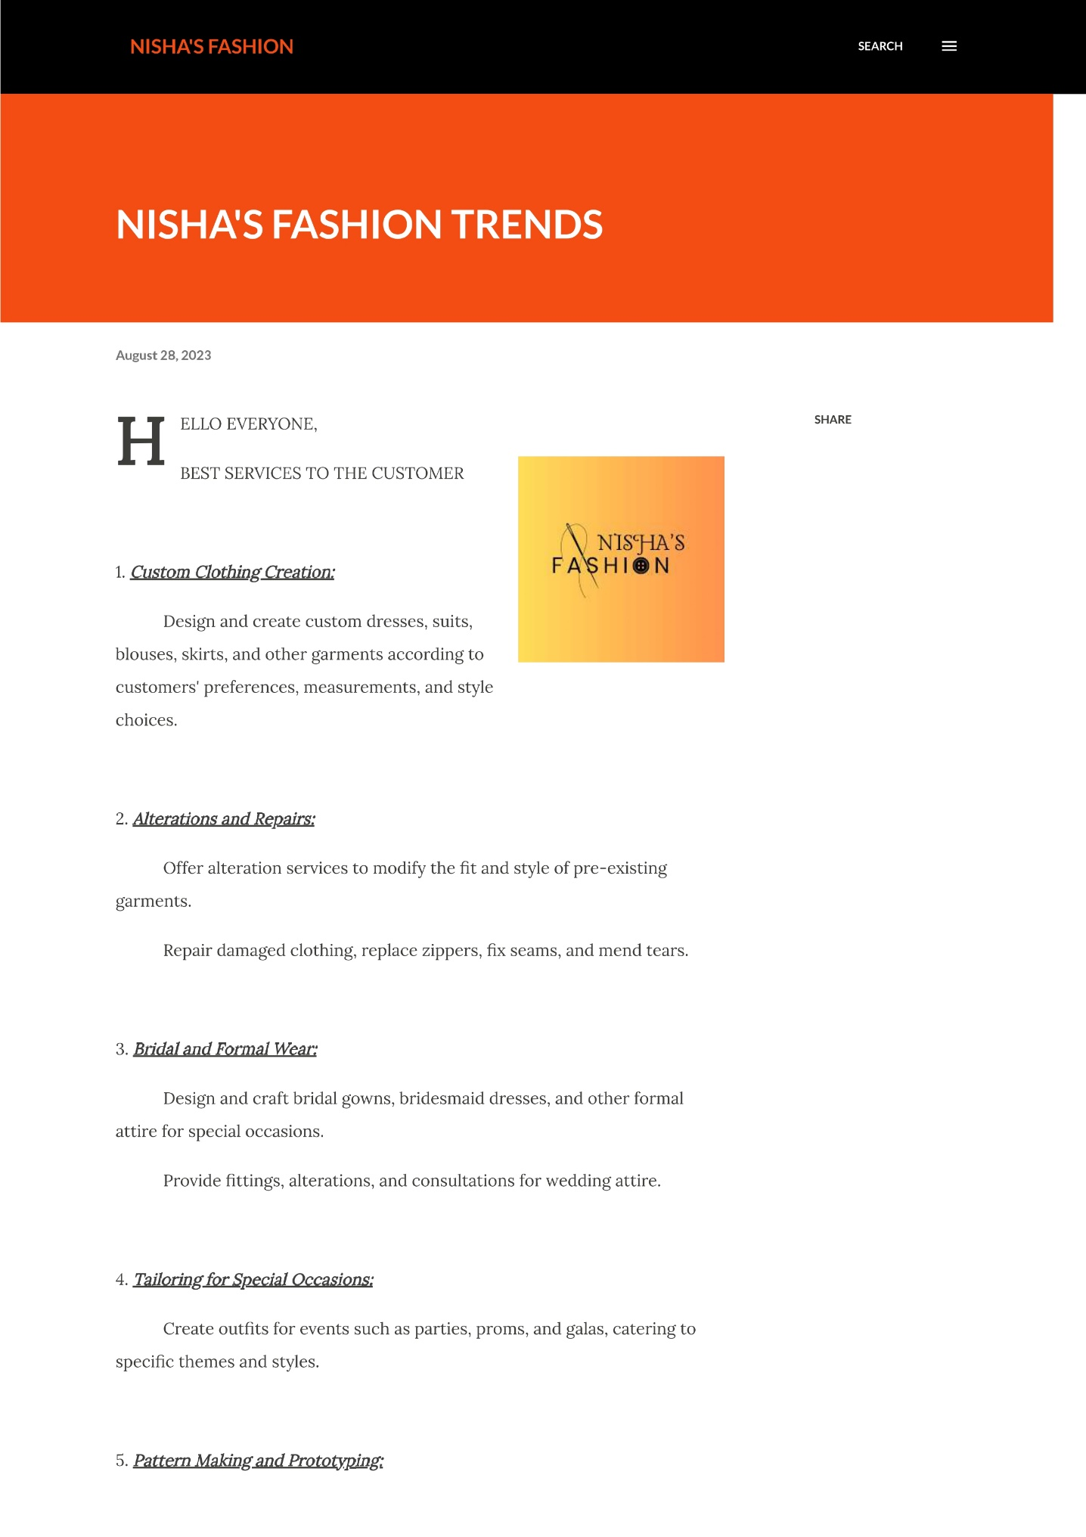Link: <https://nishafashiontrendz.blogspot.com/2023/08/nishas-fashion-trends.html>

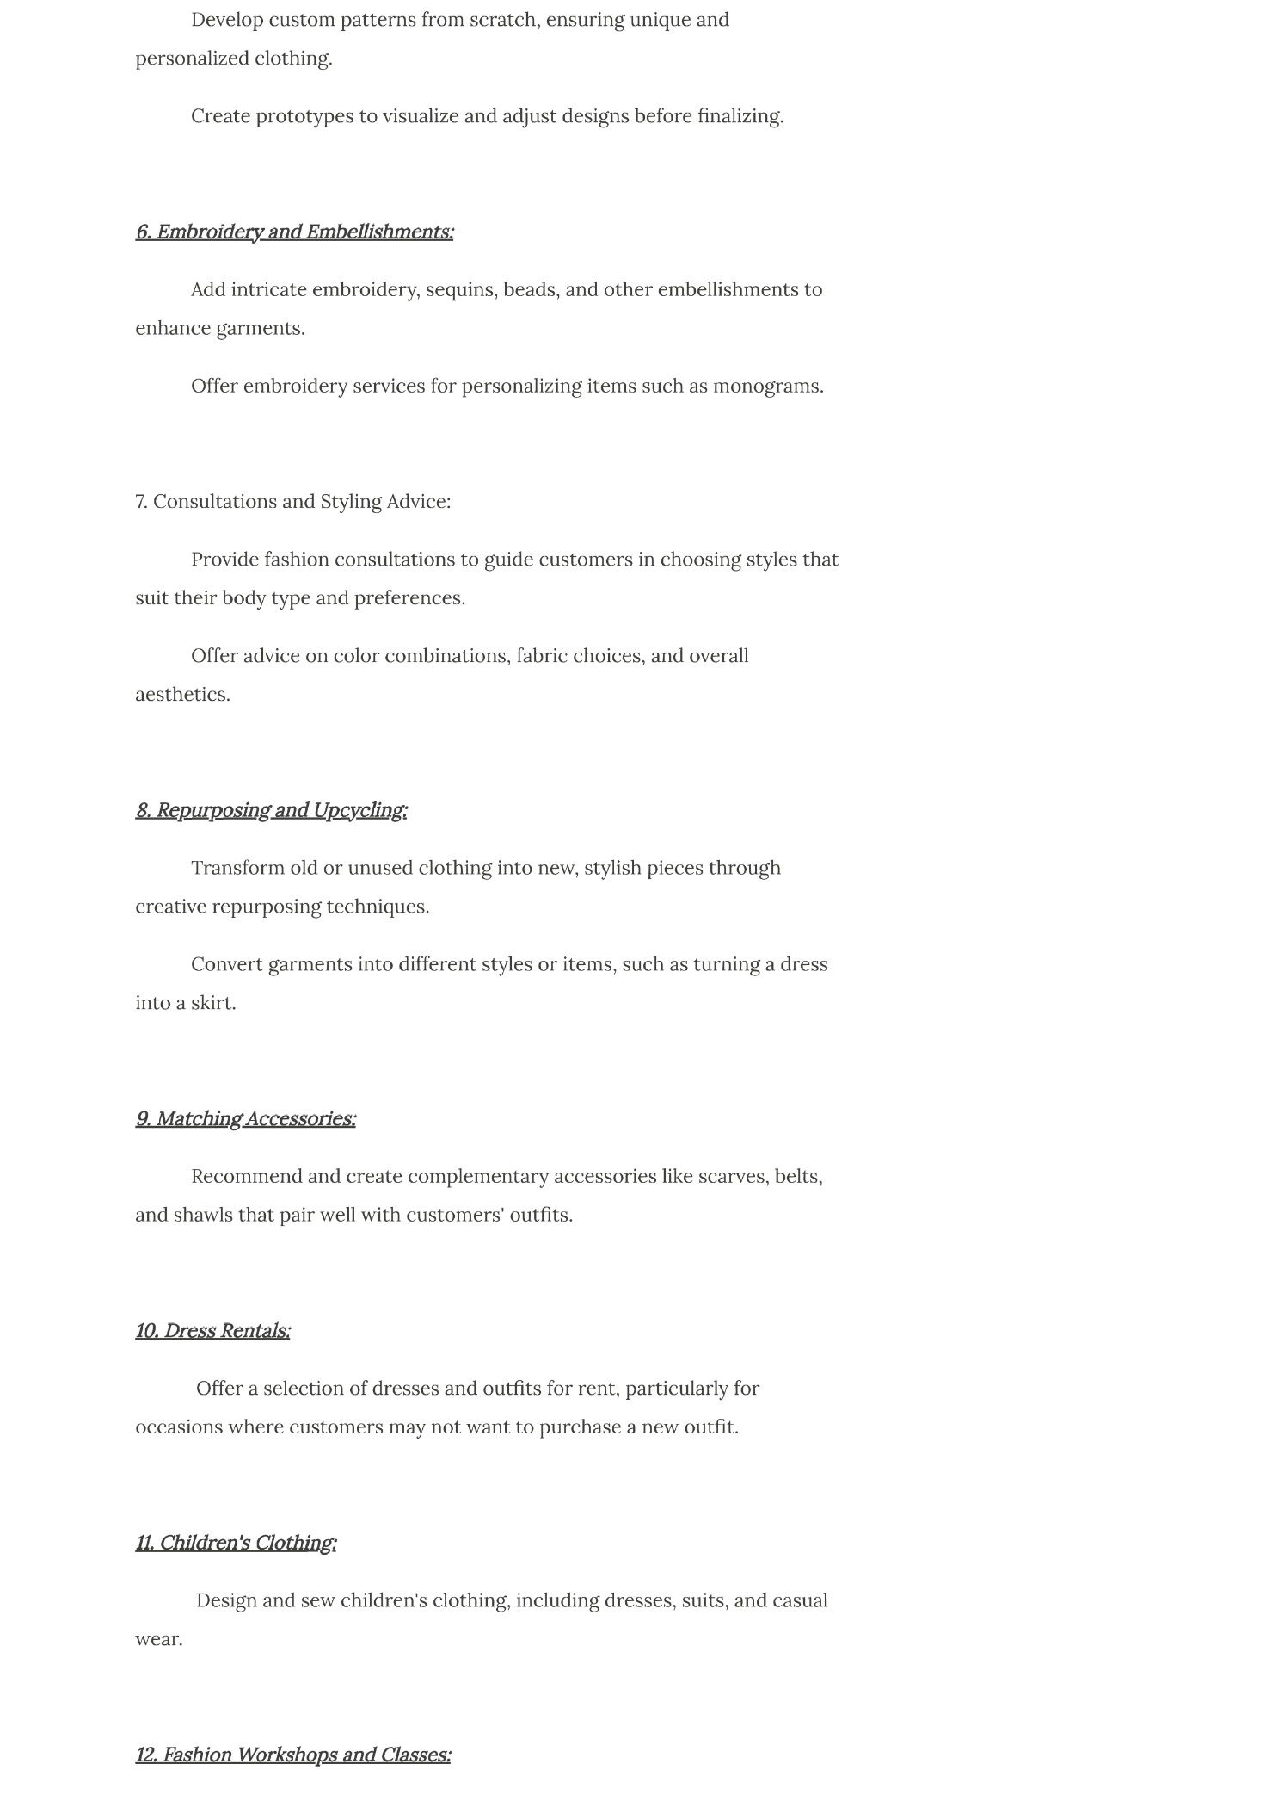

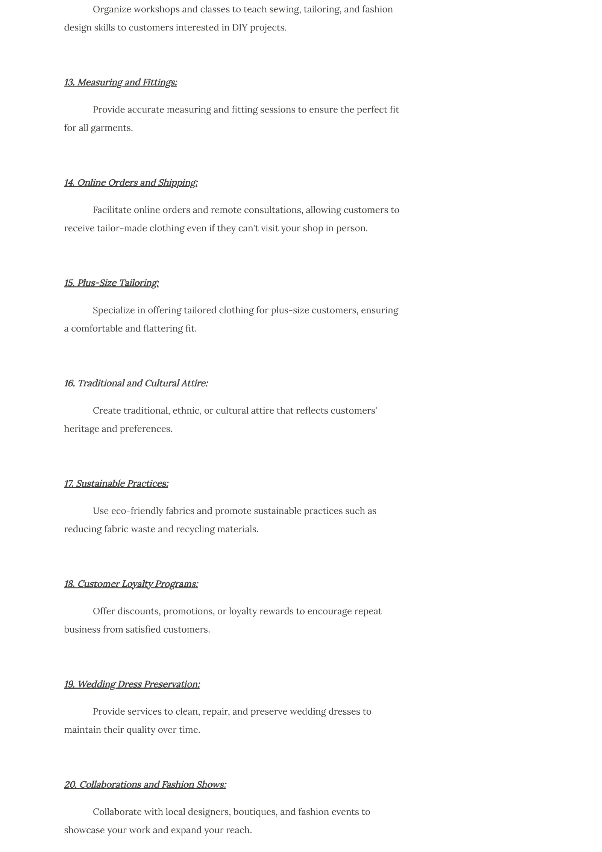

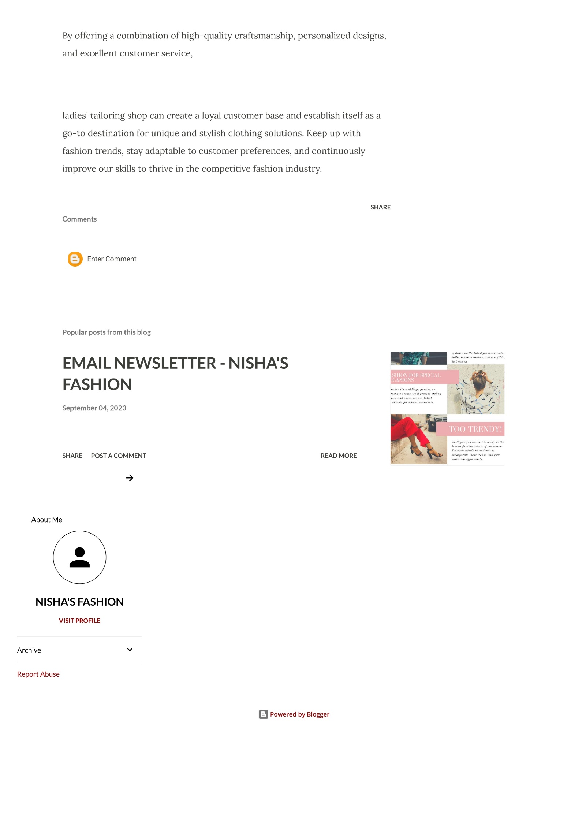

1. Create a New Facebook Business Page and post one social media poster for your brand.

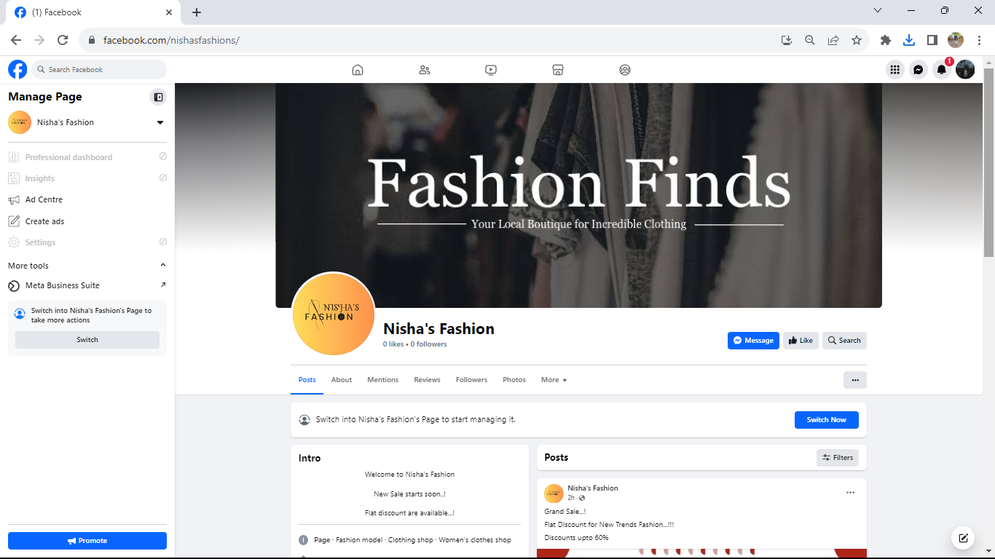Link: <https://www.facebook.com/nishasfashions>

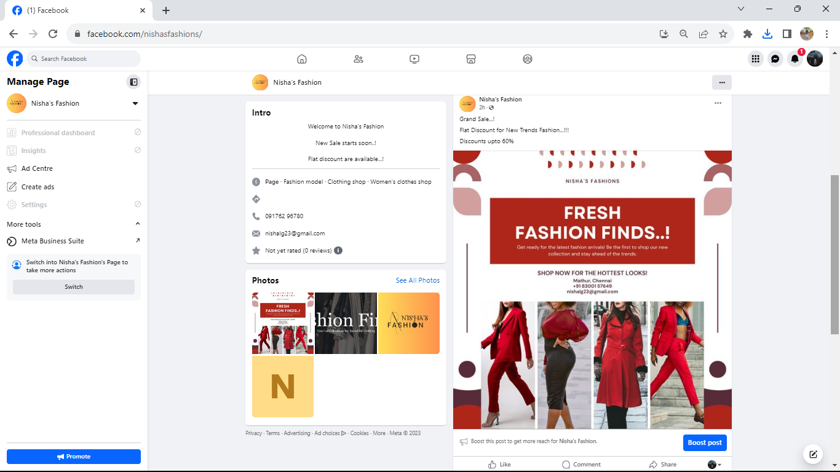

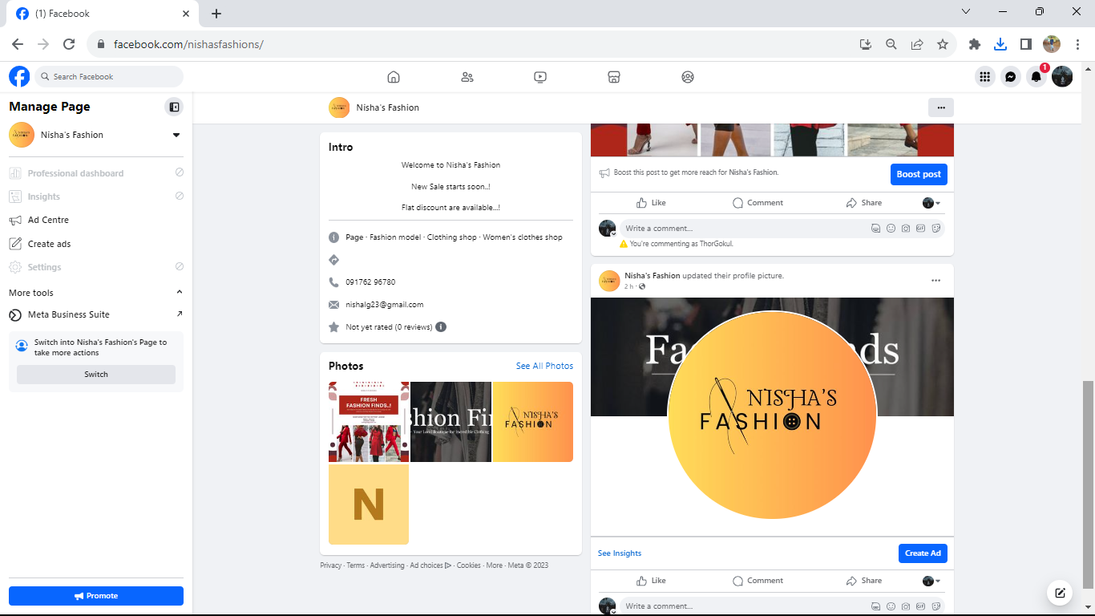

1. Create and design a social media advertisement poster using canva.

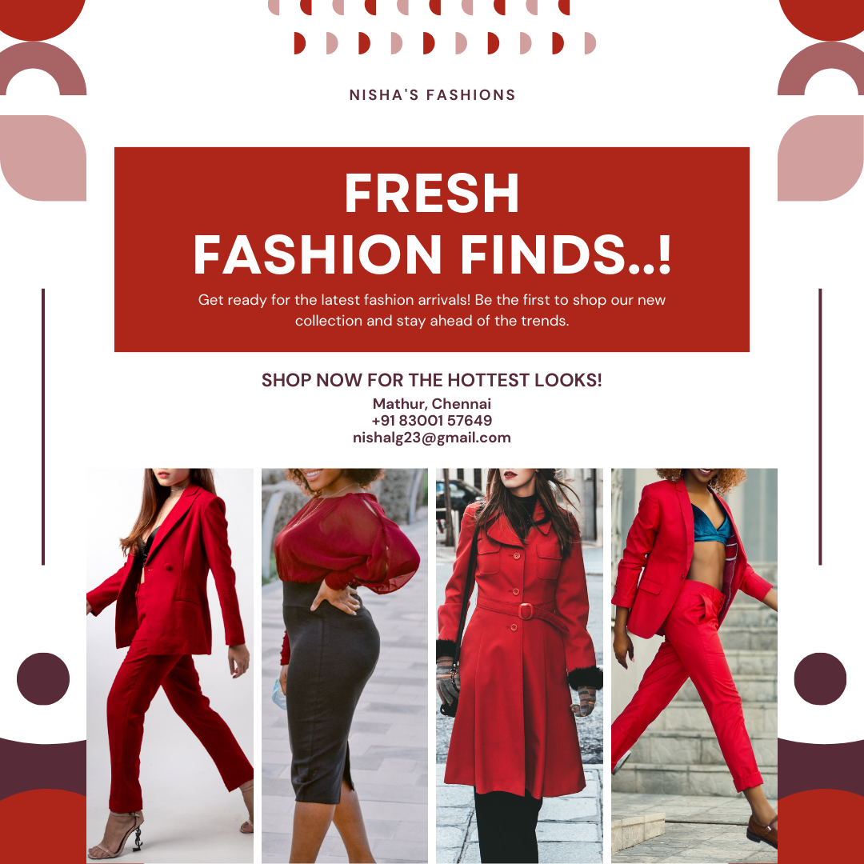

1. Create email newsletter design using MailChimp or canva tool.

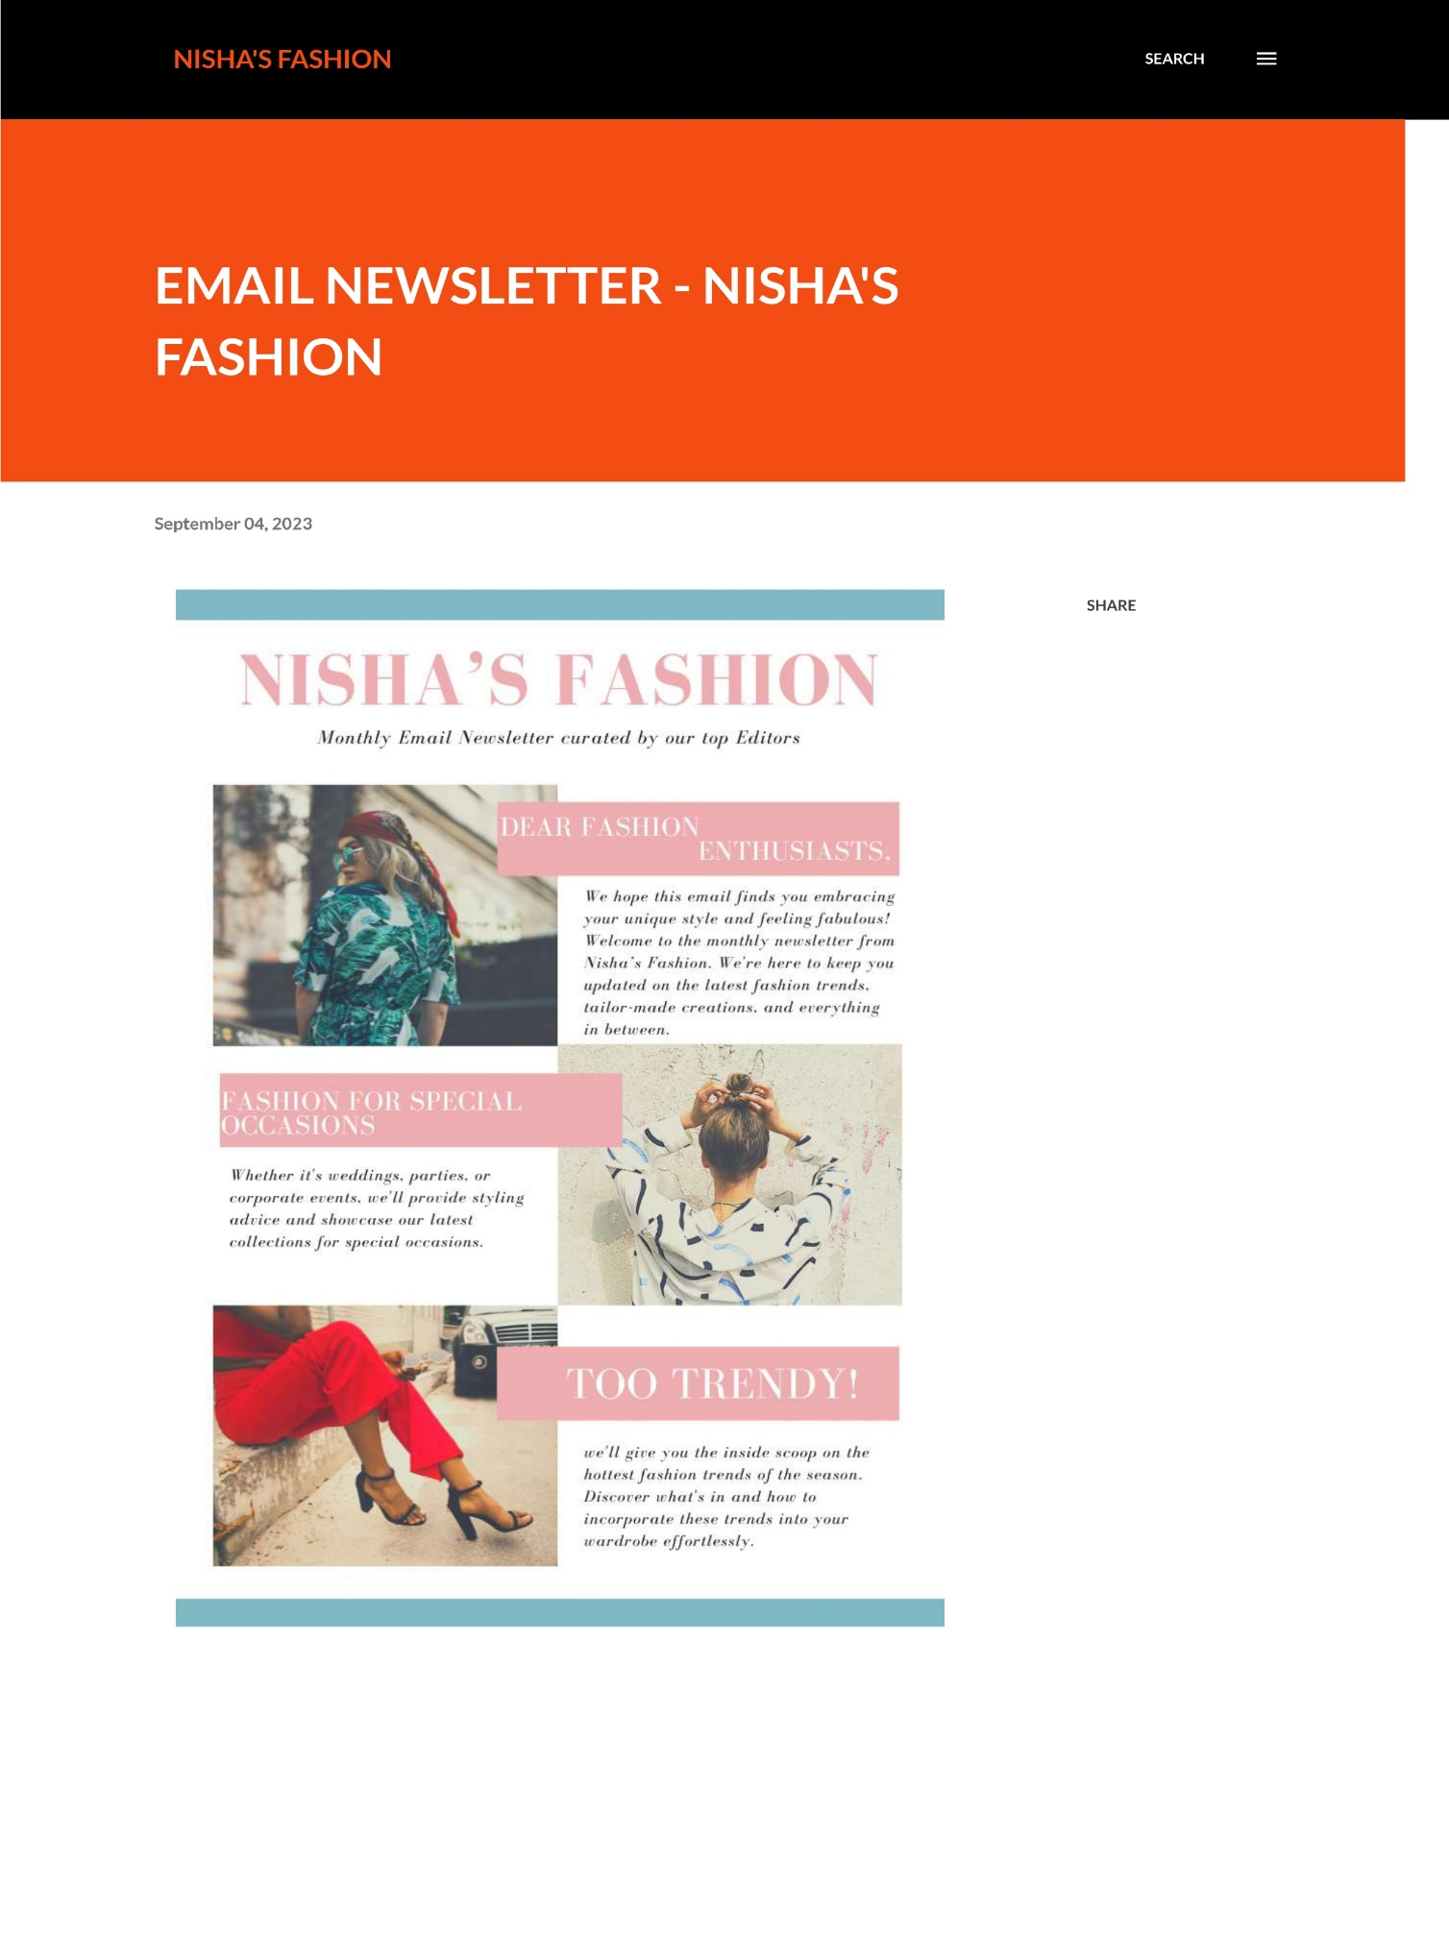Link: <https://nishafashiontrendz.blogspot.com/2023/09/email-newsletter-nishas-fashion.html>

